**Metric on validation dataset of ‘COLING_2025’**

| **Model** | **F1(macro)** | **Precision** | **Recall** | **Accuracy** |
| --- | --- | --- | --- | --- |
| **Deberta-v3-large** | 0.80800 | 0.824036 | 0.80800 | 0.794713 |
| **xlm-roberta-anli** | 0.782667 | 0.804238 | 0.804238 | 0.756587 |
| **roberta-openai-detector** | 0.796 | 0.779799 | 0.802808 | 0.79600 |
| **roberta-large** | 0.72933 | 0.7015920 | 0.738536 | 0.729333 |
| **Deberta-v3-large**  **(first five encoder layer frozen)** | 0.834667 | 0.841713 | 0.834667 | 0.83851 |
| **Xlm-roberta**  **(first five encoder layer frozen)** | 0.748 | 0.7497 | 0.7480 | 0.736361 |
| **Roberta-openai-detector**  **(first five layers frozen)** | 0.748 | 0.7497 | 0.748 | 0.7363 |
| **Roberta-large**  **(first five layers frozen)** | 0.77066 | 0.794425 | 0.770667 | 0.751972 |
| **bert-base-multilingual-cased** | 0.779446 | 0.788638 | 0.789333 | 0.789333 |
| **longformer** | 0.837730 | 0.859685 | 0.845333 | 0.845333 |
| **vicuna-7b** | 0.821649 | 0.852566 | 0.833333 | 0.833333 |
| **ai-text-detector** | 0.496165 | 0.406194 | 0.637333 | 0.637333 |

**Metric on test set of ‘COLING_2025’**

| **Model**  **(ensembling type)** | **F1(macro)** | **Precision** | **Recall** | **Accuracy** |
| --- | --- | --- | --- | --- |
| **Bagging**  **(Decision Tree Classifier)** | 0.839900 | 0.8419 | 0.843027 | 0.8400 |
| **Bagging**  **(SVC)** | 0.832449 | 0.832483 | 0.832425 | 0.8325 |
| **Voting**  **(soft)** | 0.832449 | 0.832483 | 0.832425 | 0.8325 |
| **Voting**  **(hard)** | 0.837499 | .837785 | 0.837726 | 0.8375 |
| **Gradient Boosting Classifier** | 0.8249 | 0.8264 | 0.8255 | 0.8250 |
| **Stacking**  **(rf,xgb,lgb,catboost and final model is Gradient Boosting Classifier)** | 0.8199 | 0.8218 | 0.8218 | 0.8200 |

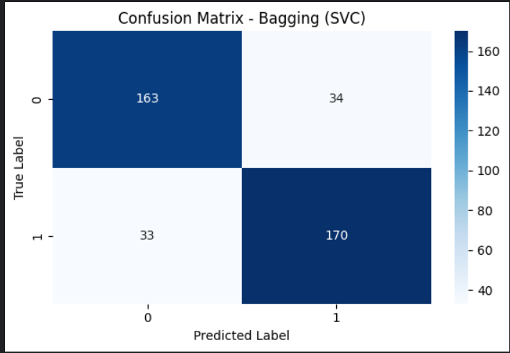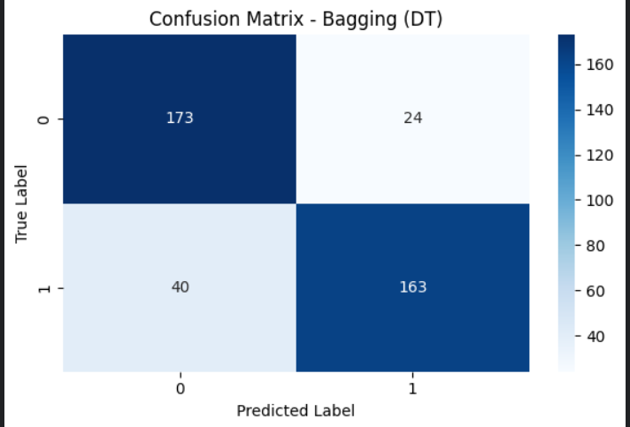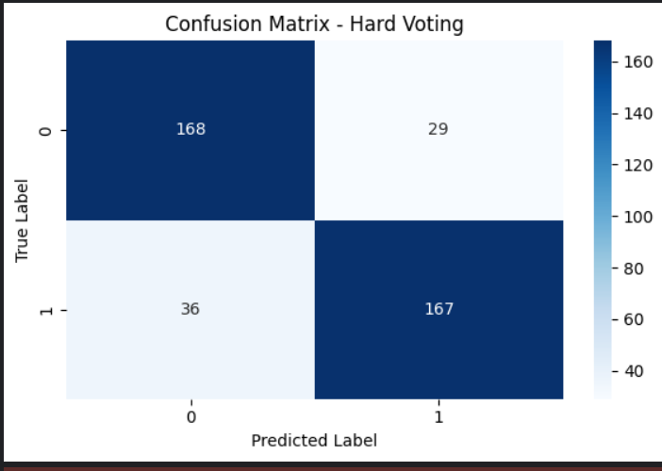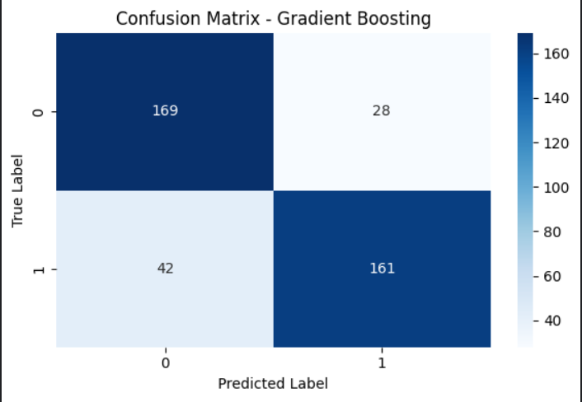

**Evaluation metric on ‘PAN CIEF’**

| **Model** | **F1(macro)** | **Precision** | **Recall** | **Accuracy** |
| --- | --- | --- | --- | --- |
| **Deberta-v3-large** | 0.976762 | 0.976830 | 0.976800 | 0.976800 |
| **roberta-openai-detector-large** | 0.963001 | 0.963829 | 0.963200 | 0.963200 |
| **roberta-large** | 0.965421 | 0.965948 | 0.965600 | 0.965600 |
| **xlm-roberta-xnli** | 0.949870 | 0.951714 | 0.950400 | 0.950400 |
| **longformer** | 0.958081 | 0.959475 | 0.9584 | 0.9584 |
| **bert-base-multilingual-cased** | 0.958215 | 0.958662 | 0.958400 | 0.958400 |
| **vicuna-7b** | 0.975103 | 0.975487 | 0.975200 | 0.975200 |
| **e5-small** | 0.934169 | 0.939085 | 0.935200 | 0.935200 |

**Metric on test set of ‘COLING_2025’ using top 4 models(deberta-v3-large,deberta-v3-large(first five layer frozen),radar-vicuna7b,longformer-4096)**

| **Model**  **(ensembling type)** | **F1(macro)** | **Precision** | **Recall** | **Accuracy** |
| --- | --- | --- | --- | --- |
| **Bagging**  **(Decision Tree Classifier)** | 0.839936 | 0.841445 | 0.840489 | 0.8400 |
| **Bagging**  **(SVC)** | 0.872480 | 0.832483 | 0.872509 | 0.8725 |
| **Voting**  **(soft)** | 0.855000 | 0.855192 | 0.855192 | 0.8550 |
| **Voting**  **(hard)** | 0.852492 | 0.853043 | 0.852804 | 0.8525 |
| **Gradient Boosting Classifier** | 0.852499 | 0.852791 | 0.852729 | 0.8525 |
| **Stacking**  **(rf,xgb,lgb,catboost and final model is Gradient Boosting Classifier)** | 0.827447 | 0.828697 | 0.827949 | 0.8275 |